Carolingian and Variations
with
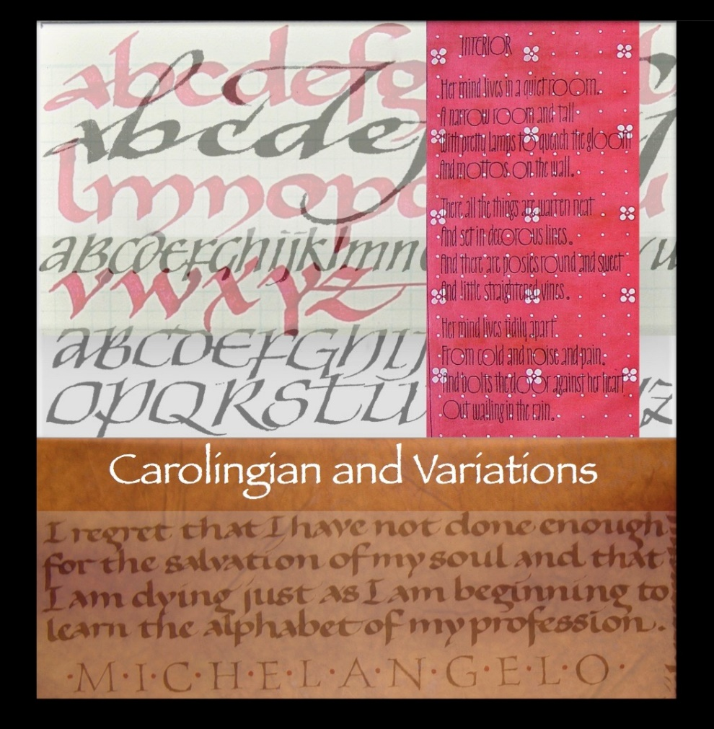
Reggie Ezell

The basic version of Carolingian we will start with has everything to do with directness, rhythm, and enjoyment (fun). Twenty-one of the twenty-six letters are done in a single stroke. We will generate contemporary versions changing not only the forms but the writing implements used to make them as well.
Beginners through advanced welcome.

Reggie Ezell is well respected as a teacher of calligraphy, and has travelled extensively presenting his year-long courses, Twenty-Six Seeds to Grow and From Primitive to Modern. In the last few years, he has created DVD’s of the basic alphabets and accompanying portfolios with exemplars, instructions, guidelines, stroke sequence guide, and nib equivalency guides. The Carolingian DVD and Portfolio (a $25 value) are included in the supply fee for the class.

October 26 - 27, 2019
9:00 a.m. – 5:00 p.m. Saturday and 10:00 a.m. -6:00 p.m. Sunday
Zionsville Town Hall
1100 W Oak St, Zionsville, IN 46077

Cost (including $25 supply fee):
Members: $165, Non-members: $190

Supplies:
Bring: calligraphy grid pad, straight pen handle of personal choice, nibs of your choice
Provided: Most papers, most writing fluids, some nibs

More Info: Kathleen Rollick kathleen.rollick@gmail.com

To register online using PayPal, visit the events page of https://www.calligin.org/ by October 20.

To register by mail, please let Kathleen Rollick know you will be attending and mail your check, made payable to CALLIGRAPHY GUILD OF INDIANA (CGI) to
Charlotte Schrock
5735 Carvel Ave.
Indianapolis, IN 46220

