Expressing the Text
with
Margaret Soucy-Lowry

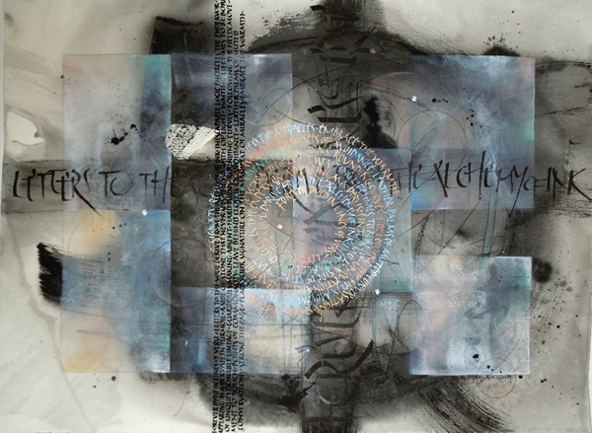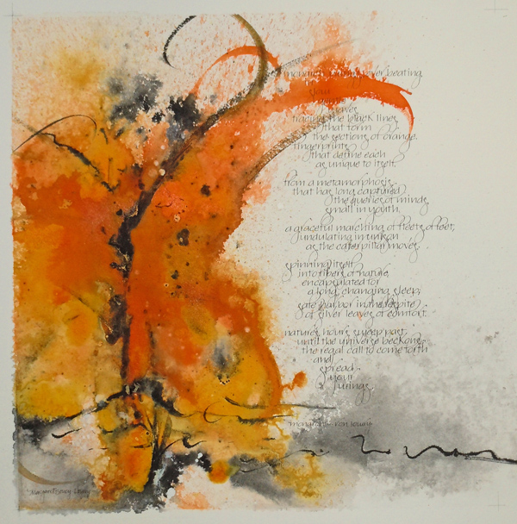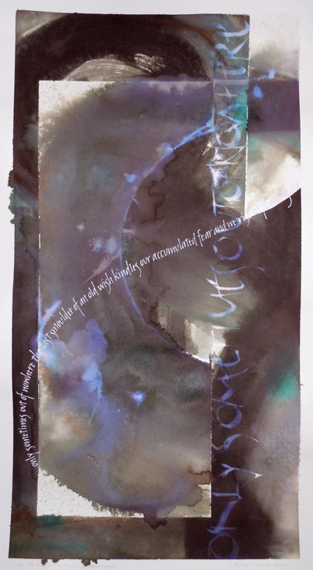

This workshop focuses on the creative process as applied to calligraphy. It will be a guided sharing to cultivate depth in your work by developing processes to create a meaningful and revealing dialog with words through a series of exercises and discussions. All skill levels are welcome.

Margaret Soucy Lowry is member of the Calligraphy Guild of Indiana and sign artist at Trader Joe's #640. She holds degrees in both Visual Fine Arts and Graphic Design. Over the years, she has done countless commissions, exhibited widely in New England and Indiana, had her historical writing published in Script and Scribble by Kitty Burns Florey, and taught numerous workshops at the Artistic Designs Gallery in Brownsburg. When working with text, Margaret strives to integrate letterforms with a conceptual background that she conceives, using whatever skills and techniques necessary to bring a visual interpretation of text or concept into being.

January 26 - 27, 2019
10:00 a.m. – 4:00 p.m. Saturday and Sunday
Zionsville Town Hall, Room 205 - 1100 W Oak St, Zionsville, IN 46077
Cost: $110 by January 6 (early bird special!); $125 after January 6
More Info: Kathleen Rollick kathleen.rollick@gmail.com

Notes:
- In the event of inclement weather on the scheduled weekend, workshop will be rescheduled for February 23-24
- Since registration for this workshop overlaps with the membership renewal period, there are not separate prices for members and non-members. Please be sure to renew your membership (or join the guild!) before registering.

To register online using PayPal, visit the events page of https://www.calligin.org/ by January 20.

To register by mail, please let Kathleen Rollick know you will be attending and mail your check, made payable to CALLIGRAPHY GUILD OF INDIANA (CGI) to
Charlotte Schrock
5735 Carvel Ave.
Indianapolis, IN 46220

