Traditional Gilding
with
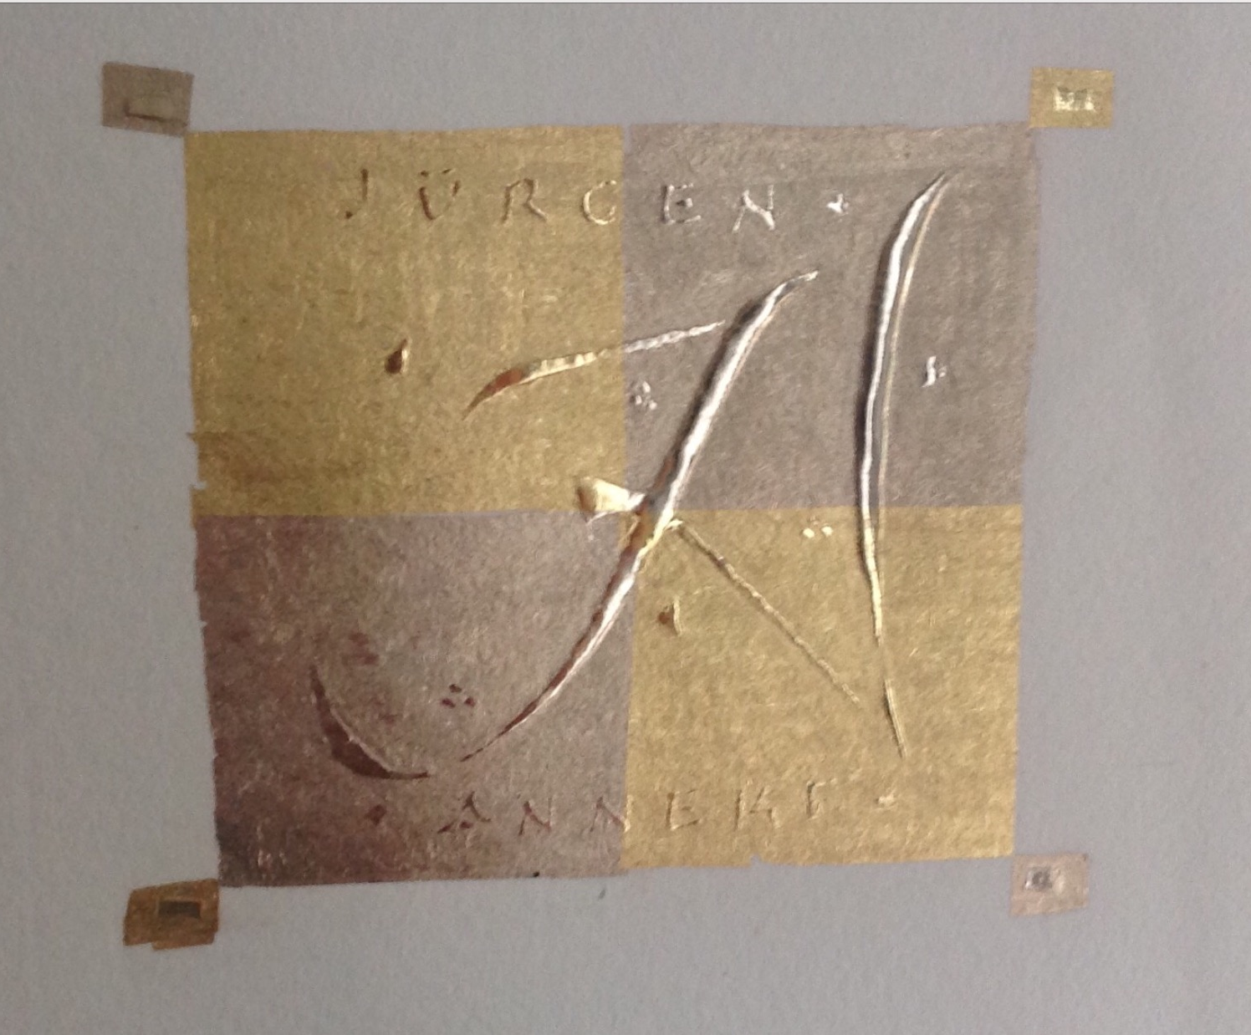
Peter Thornton
To what cannot you compel the hearts of men, O cursed lust for gold. Virgil

This 2 day workshop on Traditional gilding will be a very practical class that will focus on the few essential skills required and the simple tools used in this often thought difficult area of our craft.
We will begin by gilding pre-prepared small areas/shapes of gesso and letters before laying and gilding our own to learn the complete procedure of this 'glamorous' area of our craft. The workshop will cover:

- The making of traditional gesso
- The laying and preparation of the gesso
- A simple method of cutting the gold leaf
- Laying and burnishing the gold leaf
- Drawing letters and other designs and motifs
- Laying gold leaf as a background without gesso.

This small-group (8 person maximum) class can be for ALL levels though perhaps more suited to those with some experience.

April 28 - 29, 2019
Sunday: 10:00 a.m. – 6:00 p.m. and
Monday 9:00 a.m – 5:00 p.m.
Zionsville Town Hall, Room 205 - 1100 W Oak St, Zionsville, IN 46077
Cost: $150 for members; $175 for non-members (includes membership)
More Info: Kathleen Rollick kathleen.rollick@gmail.com

To register online using PayPal, visit the events page of https://www.calligin.org/ by April 17.

To register by mail, please let Kathleen Rollick know you will be attending and mail your check, made payable to CALLIGRAPHY GUILD OF INDIANA (CGI) to
Charlotte Schrock
5735 Carvel Ave.
Indianapolis, IN 46220

