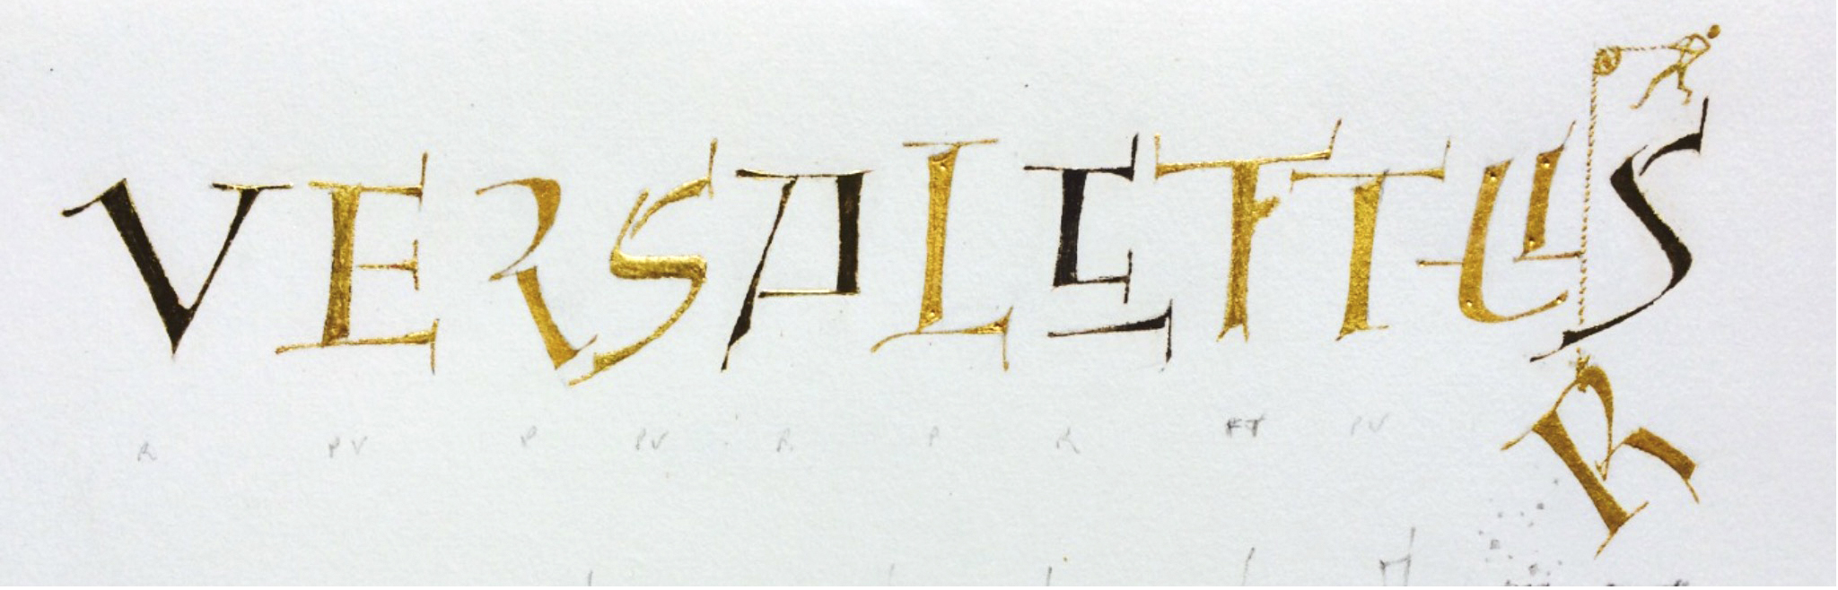
With Peter Thornton

This one day w/shop will be a gentle introduction to the (12th / 13th cent.) decorative Versal capital letter and modern variants.

We shall be working with the 'normal' and conventional Versal letter. First in pencil before moving on to pen and ink or gouache. There will be many short and helpful exercises and projects throughout to show why this major capital and colourful letter lasted for over 500 years. It was first used as a functional and beautiful 'signpost to the reader' before being used in important words and opening sentences and paragraphs.

MATERIAL LIST
*Pencils, HB and if poss. 4B or 8B Derwent Wash. (Sharpening sand paper block)
*Borden and Riley Layout pad #37 (highly recommended) or similar. 11" X 8.5" or 11" X 14" or 11" X 17"
* A sheet or two of any better quality paper, e.g. Arches Text Wove, Arches MBM, Fabriano Ingres, Rives BFK or similar.
* Small nibs, Rexel size 4, Brause or Tape 1.5mm, 1mm and/or smaller.
* Gouache AND watercolours of your choice.
* Old brushes to load your nibs

Saturday, April 27, 2019
9:00 a.m. – 5:00 p.m.
Zionsville Town Hall, Room 205 - 1100 W Oak St, Zionsville, IN 46077
Cost: $75 for members; $100 for non-members (includes membership)
More Info: Kathleen Rollick kathleen.rollick@gmail.com

To register online using PayPal, visit the events page of https://www.calligin.org/ by April 17.

To register by mail, please let Kathleen Rollick know you will be attending and mail your check, made payable to CALLIGRAPHY GUILD OF INDIANA (CGI) to
Charlotte Schrock
5735 Carvel Ave.
Indianapolis, IN 46220

