TOOLS & MATERIALS for Decorated Letters

www.HollyMonroe.com 513-207-2737

Big Picture: Through a series of creative exercises, you will design decorated letters on tracing paper and transfer to Twinrocker handmade paper. Working small to medium rather than larger – ballpark 6x8 – 8x10. Tools & materials, multiple pencil sketches through several creative exercises, color experiments and onto a final. Gouache will be introduced. I will go over the use of glair with gouache and touch on the simpler imitation and genuine gold techniques. Small handmade papers (circles, hearts, squares, rectangles) will be for sale. A packet of handouts will be provided for a small $5-10 fee.

Drawing & Painting Supplies:
Brushes (WN Series 7 or Miniature 7, sizes 1, 0, 00) or equivalent. Kolinsky hair
Broad-edged Pen Holder & Nibs, Mitchell or other (NIBS: 6, 5, 4, 3, 3.5, 2.5)
(or other small pen nibs you have on hand) Or pointed pen, if you prefer.
Gouache – (opaque) at least 3 colors in tubes, plus WN Zinc White and
Gold metallic gouache – Schminke (Gold Pearl) or Fine Tech (one pan or 5)
Mixing pans – 6-pan tray or favorite mixing pans for gouache/watercolor. I prefer the porcelain “flower” with 7 spaces to mix (Hobby Lobby).
Gum Arabic – powdered or liquid
Ruling pen (traditional type) to use with 6” ruler (or larger) with a raised edge
Ruler – whatever you have with raised edge. Small 6-12”
Paper – I will have Twinrocker handmade papers for sale. Bring if you have it.
Arches HP, small pieces, if you want additional paper to experiment
Tracing paper for sketching – Clearprint Design Vellum (is my fav)
Saral paper (transfer paper-graphite color) Fine Ball point pen needed to transfer
Drawing pencil (HB lead), pencil sharpener if your pencil is not an automatic
Scissors – to cut down paper
Eraser – Mars Staedtler (my fav)
Water container – to rinse brushes
Water DROPPER BOTTLE
Paint rag or paper towels
Portable Drawing Board – optional
PASTELS – If we have one box of pastels we could share, for a simple technique that helps your gouache pop…on handmade paper.

BRING SMALL INTERESTING OBJECTS that appeal to you:
3 small decorative objects for idea starters ….a favorite piece of jewelry, a sea shell, small frame with a border, fabric with pattern you like, etc.

BRING: Capital letter/Versal outlines that you would like to work with…find on-line or in a lettering book. I will provide some examples for you, as well.

CONSIDER: How will you use these decorated letters? With a quote? Initials?

See next page…..

You may order from:

Paper & Ink Arts
http://www.paperinkarts.com
800-736-7772, 8:30 am – 4:30 pm CST

or

John Neal Bookseller
http://www.johnnealbooks.com
800-369-9598

Your local art store may have some things, but often don’t carry everything.

Questions about the supply list?

Holly Monroe
513-207-2737
www.HollyMonroe.com
Letters@HollyMonroe.com

10% Discount on Pre-orders
I will be bringing some of my studio reproductions for sale. $6.50-$49.95
If you pre-order by emailing > design choices plus sizes, I will give you a 10% discount. You can view them on my website www.HollyMonroe.com > SHOP. All are on Fine Art Paper with Epson UltraChrome HD inks.

Can’t wait to see you!
All the very best,
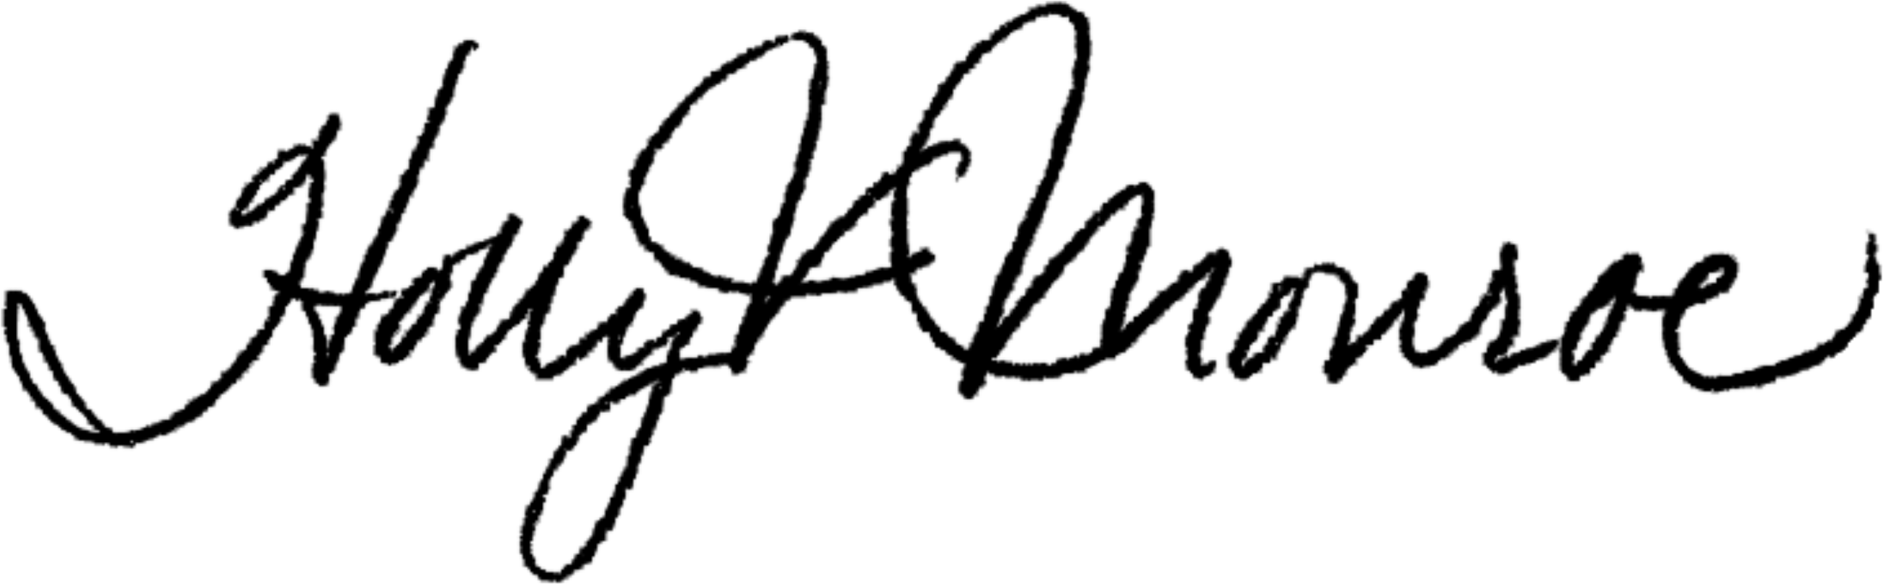

Holly V. Monroe

