Material list: BRUSH TEXTURES
Guaches  Some different colours… 3 tubes minimum  (these expires fast as we don't mix them with a lot of water)  Good Brushes;  1 W&N 995 series  (at least the smallest size one)  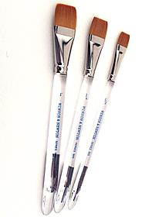  A mixing brush – not good ones  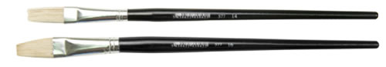  One or two papers for final piece  – aprox. A3 format  For exemple:  STONEHENGE 250 g, Arches velin is marvellous…  Or hand made papers different colours  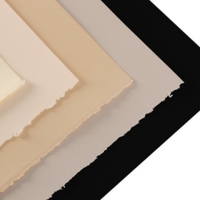 | Squared ( MUST squared ) containers  Sth Like chinese plates or the plate for the ice cubes... or this pallete with some straight edges inside...  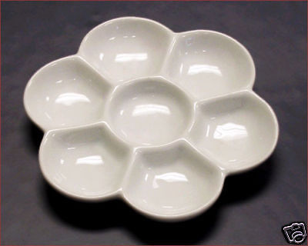  Some smaller Pads of paper for practicing with smaller sizes. (12 inch x 16 inch) – not too smooth not too rough… A3 size  I love this one!  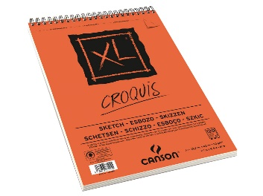  Other material:  Some texts, pencils, scissors, and water container, paper towels…  masking tape  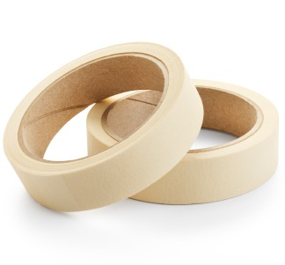  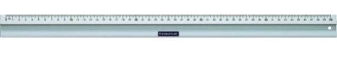  Ruler
Some material that you like to work with  (for collage, guilding, aquarell)  For a final piece – not necessary | 1 or 2 soft colored pencil PRISMACOLOR  – white, bronze or gold or colored  